Lab 4 – Preetham Thelluri

CSC3320 System Level Programming

Lab Assignment 4 - Part 1 (In- Lab)

Instructor: Fil Rondel

Purpose: Practices on the grep family commands to process texts in files.

Note: Please follow the instructions below, and write a report by answering the questions and upload the report (named as Lab4_P1_FirstNameLastName.pdf or 

Lab4_P1_FirstNameLastName.doc) to Google Classroom.

Please add the lab assignment NUMBER and your NAME at the top of your file sheet.

Open your terminal and connect to snowball server. Change your directory to your home directory (cd ~ ), and then create a new directory named as “Lab4” (mkdir Lab4). After that, go to directory Lab4 (cd Lab4) and please download the file "CSC_Course.txt" by the following command (internet access required):

cp /home/frondel/Public/CSC_Course.txt CSC_Course.txt Be sure it succeeds using “ls” to see the file name “CSC_Course.txt” listed.

Try the following commands step by step and finish the required tasks from step 4) to step 16).

Note: marks a single space.

1) $more CSC_Course.txt

Check the content of "CSC_Course.txt" using more.

Note: When viewing the file, you may need to use command f (forward one screen), b (backward one screen) and q(quit).

2) $grep 'CSC 3320' CSC_Course.txt

Note: there is a single space between "CSC" and "3320" Output the lines containing the string "CSC 3320"(search the course the number of which is "CSC 3320")

3) $grep -i 'CSC 3320' CSC_Course.txt

Output the lines containing the string "CSC 3320" via ignoring case (search the information related to CSC3320)

4) $ grep 'CSC 3' CSC_Course.txt

Attach a screenshot of the output and describe what this command does.

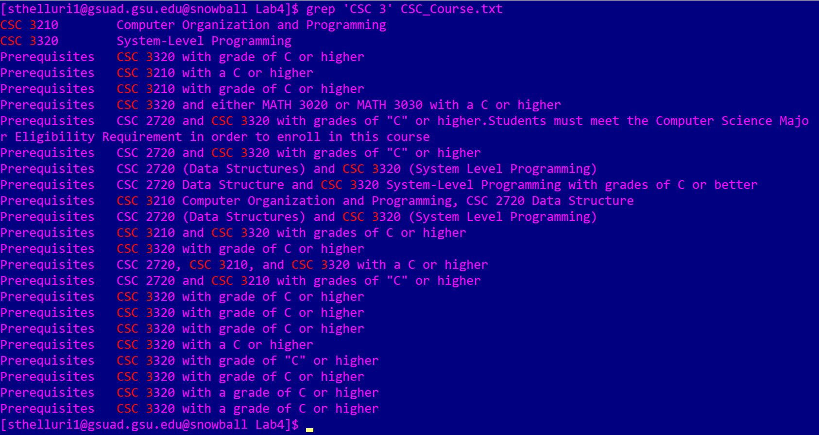

This command finds every line which contains the sequence “CSC 3.” It shows all lines where the 3000 level courses are displayed either as courses or pre-requisites.

5) $ grep 'CSC 3|CSC 1' CSC_Course.txt

Attach a screenshot of the output and describe what this command does.



There is no output here, as there is no string like ‘CSC 3|CSC 1’ in the file.

6) $ grep -E 'CSC 3|CSC 1' CSC_Course.txt

Attach a screenshot of the output and describe what this command does.

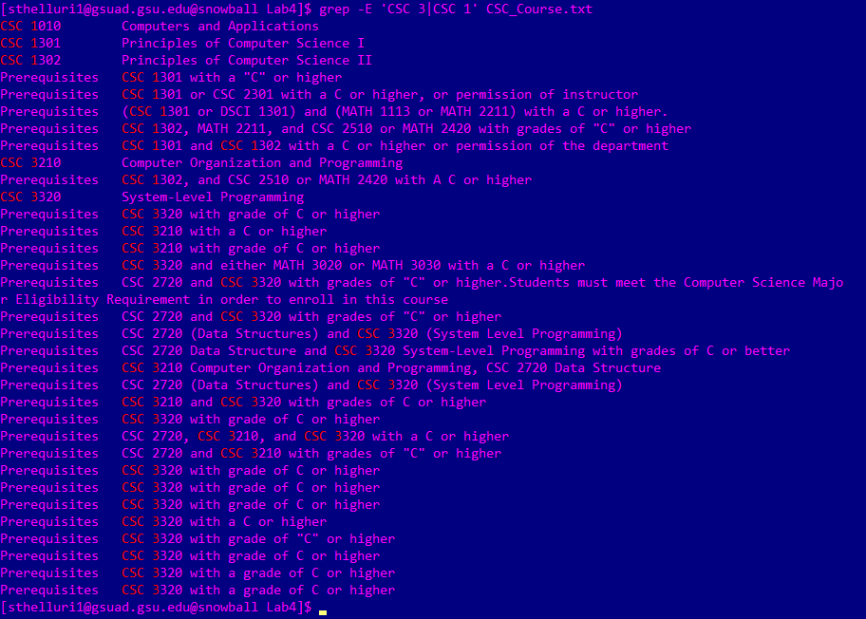

This outputs all the lines that contain either ‘CSC 3’ or ‘CSC 1.’ This one is treated as an extended regex.

Use extend regular expression

7) $ egrep 'CSC 3|CSC 1' CSC_Course.txt

Attach a screenshot of the output and describe what this command does.

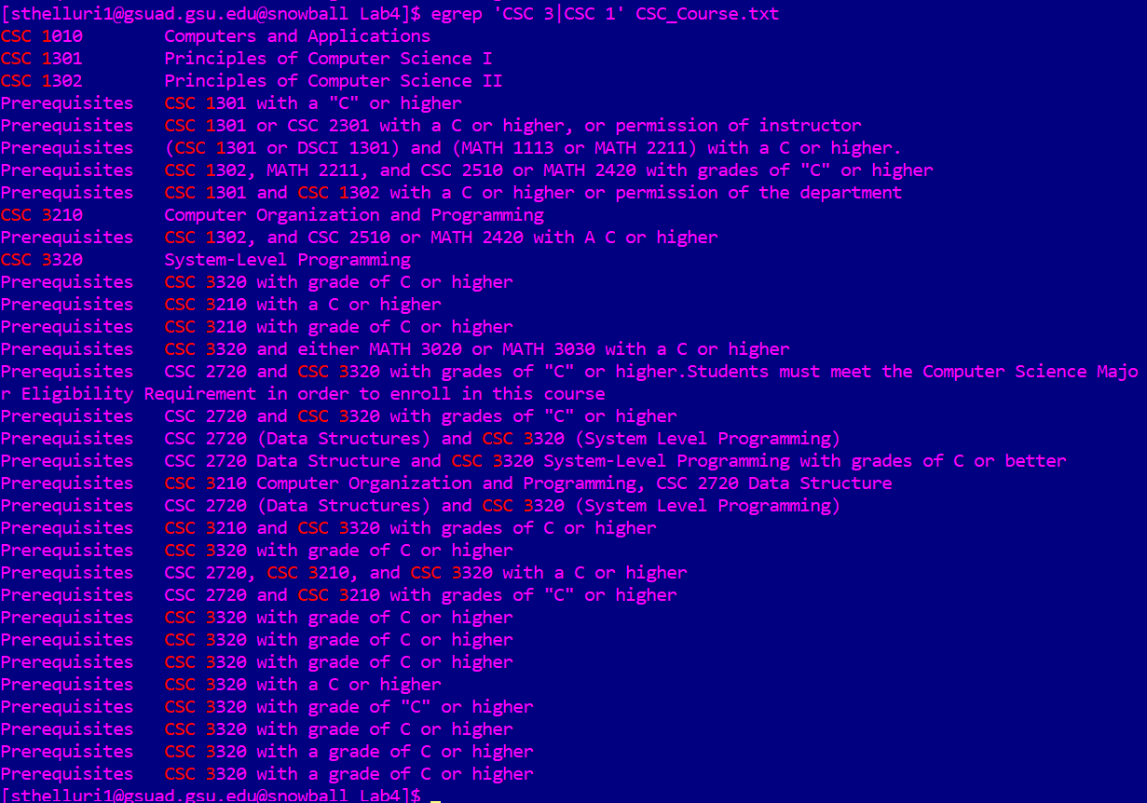

This functions just like the 6th query, as this displays all lines which contain either ‘CSC 3’ or ‘CSC 1.’ It is interpreted as an extended regular expression.

8) $ fgrep '3.000 Credit hours' CSC_Course.txt Attach a screenshot of the output and describe what this command does.



This outputs lines that contain “3.000 Credit hours.” It is taken like a fixed string and there is no direct match to this.

9) $ fgrep -x '3.000 Credit hours' CSC_Course.txt Attach a screenshot of the output and describe what this command does.



This outputs lines that have ‘3.000 Credit hours,’ but the lines that exactly match the whole line. There are no matches.

Only match the whole line

10) $ grep 'CSC.*Programming' CSC_Course.txt Attach a screenshot of the output and describe what this command does.

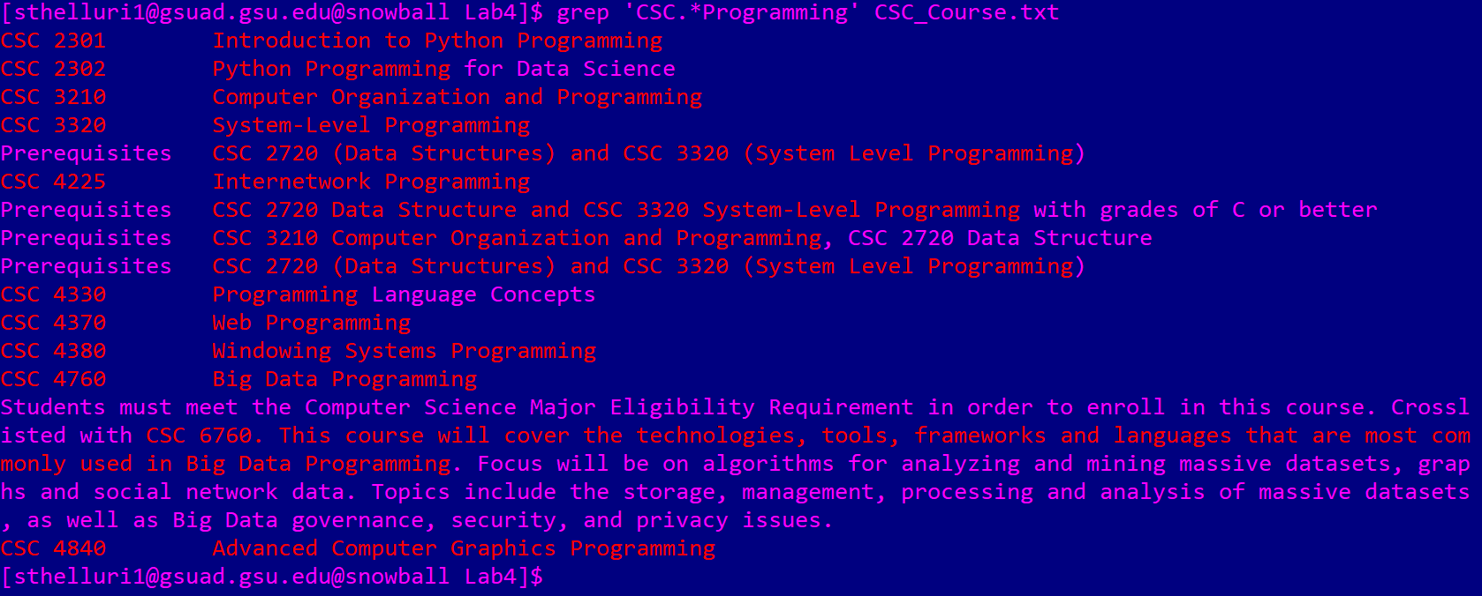

This one searches all courses related to programming. The lines to be printed should contain ‘CSC’ and end with ‘Programming’ with any number of characters in the middle. It prints whole sections when it reads in between paragraphs.

11) $ grep '^CSC.*Programming$' CSC_Course.txt Attach a screenshot of the output and describe what this command does.

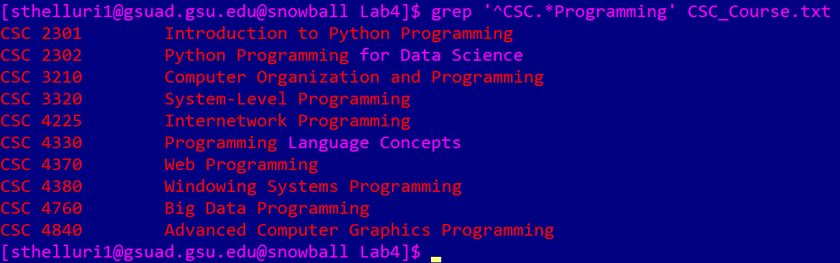

This works like the previous query, but it ONLY outputs lines that START with ‘CSC’ and end with ‘Programming.’ The “^” symbol ensures that it does not output anything that does not start with ‘CSC.’

12) $ grep --color 'CSC[^3]*3{2}' CSC_Course.txt Attach a screenshot of the output and describe what this command does.



This prints out lines that contain ‘CSC’ and have 2 ‘3’s immediately after it. It is supposed to print them out in color. But there were no matches.

No result, {} is not a special character

13) $ egrep --color -w 'CSC[^3]*3{2}[^3]*' CSC_Course.txt Attach a screenshot of the output and describe what this command does.

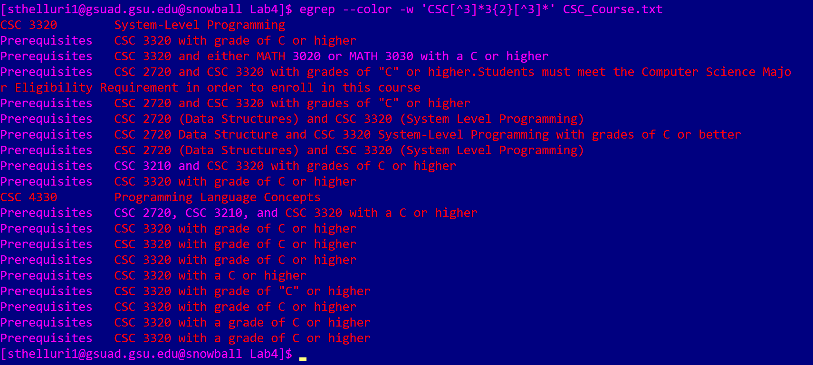

It searches and returns all the lines where courses in the file that contain ‘CSC’ and 2 ‘3’s.

-w Select only those lines containing matches that form whole words.

14) $ grep 'CSC.*C++' CSC_Course.txt

Attach a screenshot of the output and describe what this command does.



It outputs lines that contains strings which start with ‘CSC’ and end with ‘C++.’ There are no matches for this.

+ is not a special character in basic regular expression

15) $ egrep 'CSC.*C\+\+' CSC_Course.txt

Attach a screenshot of the output and describe what this command does.



This outputs lines that contain ‘CSC’ and end with ‘C++.’ There are no direct matches for this.

Convert +

16) $ egrep 'CSC.*C++' CSC_Course.txt

Please only describe what this command does.

It outputs lines that contain a string which starts with “CSC” and stop at a ‘C.’ If a line contains that pattern, the whole line is printed with the specific pattern.

2

Optional Part:

1) $ sed -E -n 's/(CSC 3[0-9]{3})(.*)/\1/p' CSC_Course.txt Attach a screenshot of the output and describe what this command does.

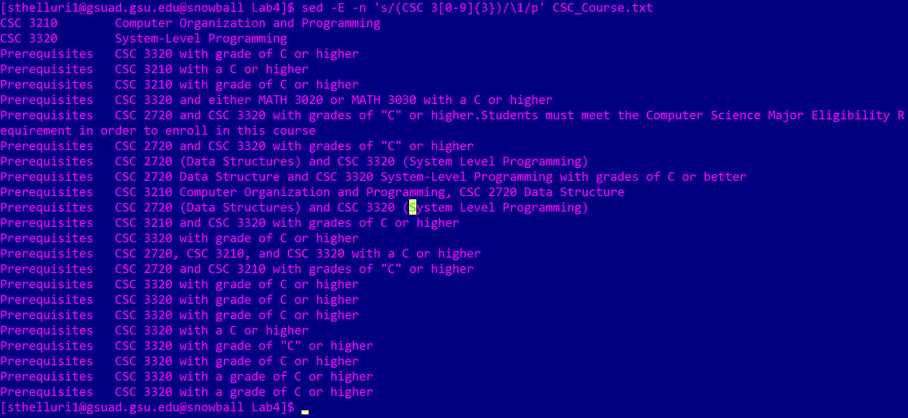

It searches through all lines that mention any 3000 level course of CSC and prints them.

2) $ awk -F'-' '/(CSC 3[0-9]{3})(.*)/{print $1}' CSC_Course.txtAttach a screenshot of the output and describe what this command does.

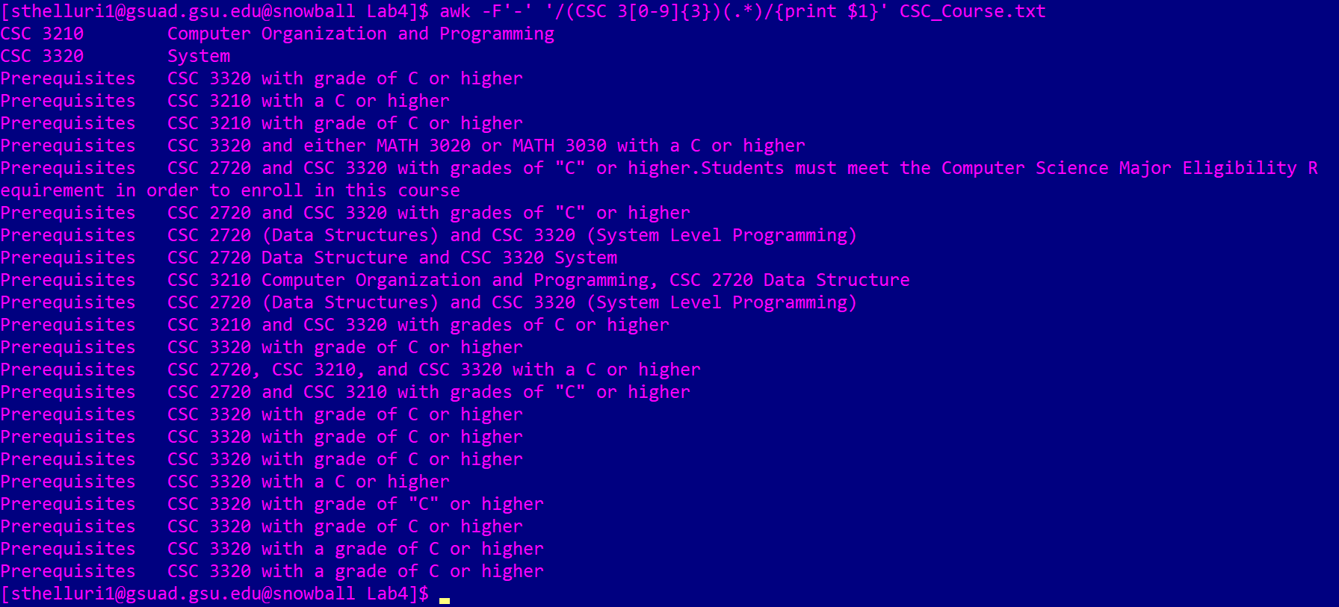

This works the same way as the previous question. It catches lines that have any mention of 3000 level CSC courses.

3) $ sed -E -n 's/(CSC [0-9]{4})( - )(.*)/\3/p' CSC_Course.txt Attach a screenshot of the output and describe what this command does.

N/A. We must replace the “-” with a “,”.

4) $ sed -E -n 's/(CSC [0-9]{4})( - )(.*)/\3/p' CSC_Course.txt| sort

N/A. You need to replace the ‘-’ with a ‘,’.

Attach a screenshot of the output and describe what this command does.